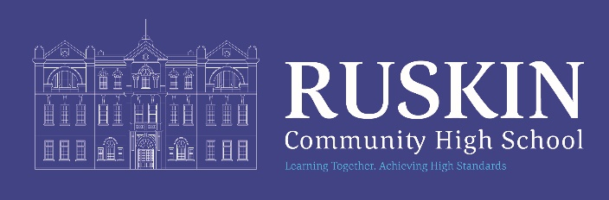
School Bus Service

The school runs a private bus service covering the North of Crewe to bring students directly to and from the school. The service is run by Gerrard’s Private Hire based in Sandbach. The cost to students to use the service is currently £1 each way and is payable to the driver on each journey.
For insurance and safeguarding purposes parent/carers are required to register with the school to use the service by calling the number below. Our service is flexible so if you require a pick up at a different point please contact Gerry on 07768 840349.

Morning journey
The journey commences at 7:40 from Bradfield Road and takes the following route: pm times are subject to school departure

Time am/pm | Pickup / Return journey drop-off points
07.40 / 15:45 | Cliffe Road bus stop (morning)  Bradfield Road (afternoon)
07.40 / 15:45 | Bradfield Road: Heron Supermarket bus stop
07:43 / 15:40 | Minshull New road: bus stop Rolls Ave
07:43 / 15:40 | Minshull New Road (bus stop before Bentley Roundabout)
07:44 / 15:35 | Frank Webb Avenue
07:50 / 15:35 | Badger Avenue: before Broad Street traffic lights
07:55 / 15:32 | Middlewich Street: Elm Drive bus stop (morning)  McColl’s Supermarket (afternoon)
07:58 / 15:30 | Elm Drive: bus stop near shops
07:59 / 15:25 | Elm Drive/Lime Tree Avenue
08:00 / 15:25 | Lime Tree Avenue: opposite Greendale Gardens
08:05 / 15:20 | Queens Street: Sea Cadets building
08.20 / 15:15 | Arrival / Departure Ruskin
 | Additional afternoon drop offs available on request, ask the driver please.

Updated: June 26 for September 2026
Migrateddocuments/admin/admin/mainoffice/schoolbus/2026-2027

