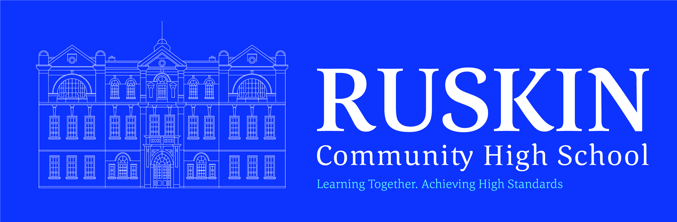

POLICY INFORMATION STATUTORY

Name of Policy/Procedure: BEHAVIOUR POLICY
Coronavirus addendum

Original date drawn up: Autumn Term 2020
Original date adopted:
Current version date: Autumn Term 2021
Review cycle: Annually
Next review date: As and when required

Adopted by the Governing Body of Ruskin Community High School

Signed (Chair of Governors):

Reviewed by | Date | Approved
Marcia Garnett | Autumn Term 2020 | FGB 23/11/2020
Emma Szymura | Autumn Term 2021 | FGB 22/11/2021

Contents
1. Scope 2
2. Expectations for Students in school 2
3. Expectations for Students at home 4
4. Monitoring arrangements 4
5. Links with other policies 4

1. Scope
This addendum applies until further notice.
It sets out changes and exceptions to our normal behaviour policy. Students, parents and staff should continue to follow our normal behaviour policy with respect to anything not covered in this addendum.
We may need to amend or add to this addendum as circumstances or official guidance changes. We will communicate any changes to staff, parents and Students.

2. Expectations for Students in school
2.1 New rules
When Students are in school, we expect them to follow all of the rules set out below to keep themselves and the rest of the school community safe.
Staff will be familiar with these rules and make sure they are followed consistently.
Parents should also read the rules and ensure that their children follow the new procedures that have been put in place. Parents should contact the relevant Year Achievement Manager (YAM) if they think their child might not be able to comply with some or all of the rules, so we can consider alternative arrangements with them and support them to integrate back into school life.
School attendance is mandatory, so the usual rules on attendance apply.
However, some Students will be unable to attend so they can self-isolate, because they:
Have had symptoms or a positive test result
Live with someone who has symptoms or has tested positive and are a household contact
Are a close contact of someone who has coronavirus
Clinically extremely vulnerable Students are expected to attend school unless they have been specifically advised by their GP or clinician not to attend.
Equipment and resources can be shared within groups
Classroom-based resources like books and games can be used and shared within a group. These are cleaned regularly.
However, people still shouldn't share individual and very frequently used equipment like pencils and pens.
Any resources shared between groups, such as sports, art and science equipment, are either:
Cleaned frequently and meticulously, and always between groups using them; or
Rotated so they can be unused and out of reach for a period of 48 hours (72 hours for plastics) between use by different groups
Currently, Students (year 7 and above), staff and visitors should wear face coverings in shared areas (not classrooms).

Students aged 11 and over should also wear face coverings on public transport including the school bus.
However, some people are exempt from wearing these coverings and they have been issued with an exemption card.
All year groups have a staggered start and leave time to ensure there is no interaction between year groups. All lunchtimes and break times are also staggered.
Students wash their hands upon arriving at school and at the start of lunch and break. Hands are sanitised at lesson changeover and the end of lunch and break times.
There is a one way system operated around the school and this is clearly marked.
Tissues are in all classrooms and we operate the national ‘catch it, bin it, kill it’ for sneezing and coughing.
Student must inform an adult if they are experiencing symptoms of coronavirus
2.2 Rewards and sanctions for following rules
To help encourage Students to follow the above rules, we will continue to reward Students for their positive behaviour.
However, if Students fail to follow these rules, we will implement the following:
Covid Specific Behaviours
Deliberately coughing/touching/sneezing 1 day in the Support Centre (1st offence)
2-3 days in the support centre (2nd offence)
Destroying/wasting the antibacterial hand
sanitizer Detention
Coughing/spitting in the face Exclusion
Deliberately entering another ‘bubble’ Detention (1st offence)
1 day in the support centre (if repeatedly doing it)

Abuse to staff:
(regarding spreading the virus to them)
Loud enough so staff can hear 1 day in Support Centre
To face of member of staff 2-3 days in Support Centre – exclusion

Covid Bullying:
Calling names regarding family Off timetable 1-2 days (parents informed) (1st offence)
members having the virus 1 day in Support Centre (2nd offence)

Year Managers and SLT will determine which students are placed in the School Support Centre. The Support Centre Manager will receive a list from YAMs by 4pm each day.

3. Expectations for Students at home
3.1 Remote learning rules
If Students are not in school, we expect them to follow all of the rules set out below.
Parents should also read the rules and ensure their children follow them. Parents should contact the school if they think their child might not be able to comply with some or all of the rules, so we can consider alternative arrangements with them and support them with their learning.
- Be contactable during required times
- Complete work to the deadline set by teachers
- Seek help if they need it, from teachers or teaching assistants
- Alert teachers if they’re not able to complete work
- Use proper online conduct, such as using appropriate language in messages
3.2 Dealing with problems
If there are any problems with Students adhering to rules around remote learning, including if they don’t engage with the remote learning set for them, we will contact parents/carers to see if we can assist.

4. Monitoring arrangements
We will review this policy as guidance from the local authority or Department for Education is updated, and as a minimum every 4 weeks by the Senior Leadership Team (SLT). At every review, it will be approved by the full governing board.

5. Links with other policies
This policy links to the following policies and procedures:
- Child protection policy
- Behaviour policy
- Health and safety policy

