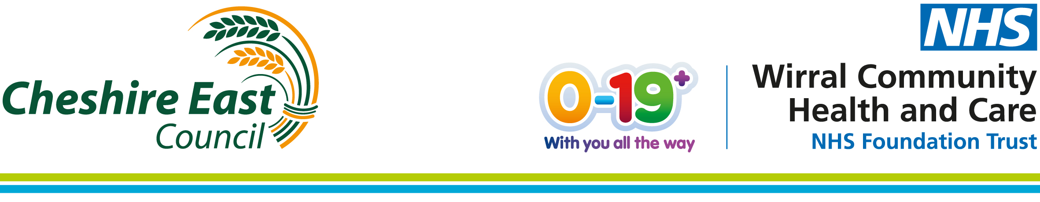

Monday 29 November 2021
Issue 4
We are approaching the end of the first phase of the Covid-19 school age immunisation programme in Cheshire East.
As of Friday 26 November, 6847 children have received the vaccination with consent from a parent or carer.
By the end of November, the school age immunisation team will have organised for vaccinations for 12-15 year olds who attend all schools across the borough. The team is currently organising several catch-up clinics for those who may have missed the opportunity to receive their vaccination at school - more information will follow over the coming week. Parents and carers can also book an appointment for their child via the national booking system - details below.
We would like to take this opportunity to thank you so much for your continued hard work and commitment.
Within this issue you will find the following updates for parents and carers:
- When your child will receive the vaccination after testing positive for Covid-19
- Tips to share with your children on the day of their vaccination
- Information about local vaccination hubs offering the Covid-19 vaccination for 12-15-year-olds
When your child will receive the vaccination after testing positive for Covid-19
If your child has tested positive for Covid-19 and is not at high risk from the virus, they need to wait 12 weeks before they can have a Covid-19 vaccine.
This starts from the date they had symptoms, or the date of the positive test if they did not have symptoms.
Tips to share with your children on the day of their vaccination
We have included some simple steps below for children to follow on the day of their vaccination:
- Don’t forget to eat your breakfast on the day of your vaccine - it’s the most important meal of the day.
- Wear a short sleeve shirt if possible - the nurse will give you the vaccine in the top of your arm. If you don’t have a short sleeve shirt don’t worry, you can roll your sleeve up or if you are wearing a fitted shirt your immuniser may ask you to loosen your tie and unbutton the top couple of buttons. This will enable the vaccination to be administered in the top of your arm.
- Wear a face mask or covering when you arrive for your vaccine*.
- The School Nurse will ask you the following questions:
  - What is your date of birth?
  - Have you had Covid-19 during the last 12 weeks?
  - Have you had the Covid-19 vaccine at your GP or a local vaccination centre?
- After having your vaccination, you will be asked to sit and wait for 15 minutes. Following this the nurse will give you an information leaflet to take away - please share this with your parent / carer. You will also receive your vaccination record card. It’s important that you keep this in a safe place.
*Exemptions apply.
Local vaccination hubs offering the Covid-19 vaccination for 12-15-year-olds
If your child has missed the opportunity to receive their vaccination at school, parents and carers can now book the vaccine online: http://nhs.uk/CovidVaccine
Local vaccination hubs are based in:
- Crewe
- Nantwich
- Northwich
- Macclesfield
- Manchester
- Winsford



