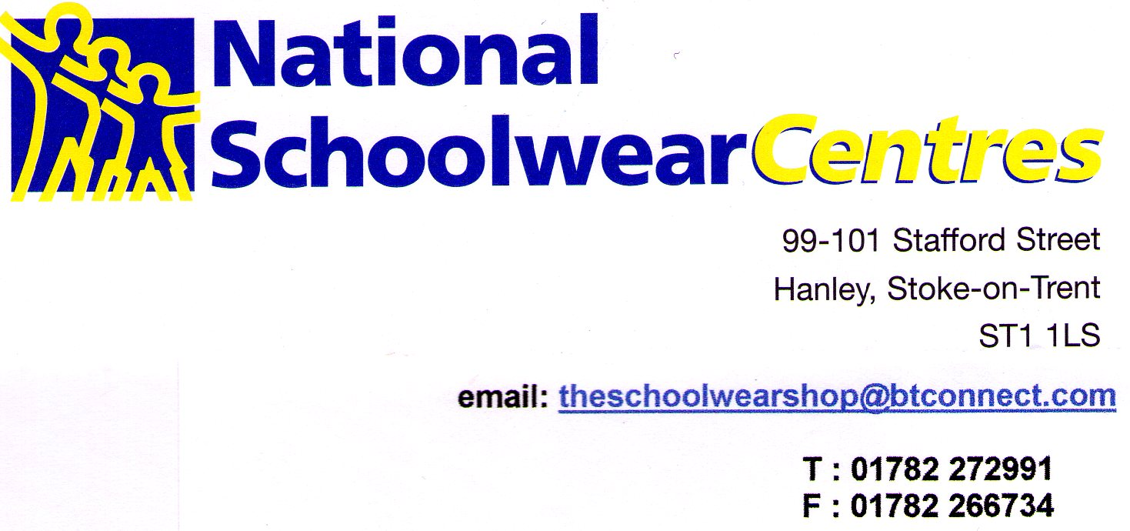

RUSKIN COMMUNITY HIGH SCHOOL
UNIFORM

National Schoolwear Centres Hanley are your new stockists of your school uniform from 1st October 2021. We offer three different ways for you to obtain your uniform.

1. We are a retail shop in Hanley City Centre, close to the shopping centre and several large car parks, we are open six days a week from 9.00am – 5.30pm Monday to Friday and 9.00am to 5.00pm Saturday. You are welcome to visit our shop and make use of our experienced staff to help with your purchases. All our staff have many years experience in schoolwear and are experts at sizing your child. We have changing room facilities and accept either cash or card payment.

2. Secondly fill in the attached order form. Either email the form to us using the email address above or call us on the shop number. We will call you back to discuss sizing and take payment. This will then be delivered into school each Wednesday for collection by your child. Prior to delivery will confirm all items and total cost.

3. Finally fill in the form as above and either email it to us or call us to discuss. If you need the items urgently we can arrange for a courier collection which usually takes 24 hours depending on the day the order is placed. This will incur a delivery cost of £5.00 per parcel

If you have questions or queries regarding stock or sizings please do not hesitate to contact us. We will do our very best to be of assistance.

Kind regards

The National Schoolwear Centres Team

