**Subject Overview.**

An overview of the curriculum covered this year in each subject. This outlines the skills and knowledge students have acquired.

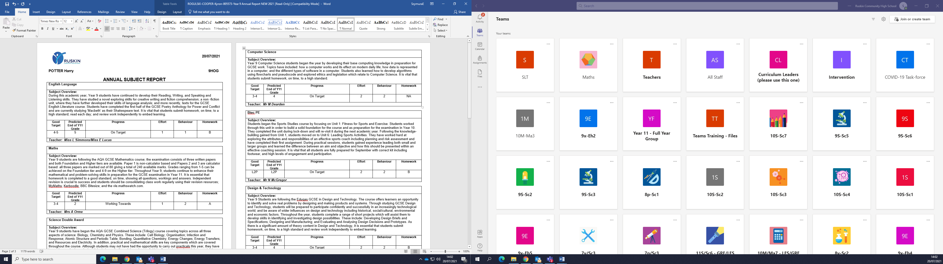

**Homework**

A. Always submitted on time to the very best of their ability.

B. Usually handed in on time and completed to a good overall standard.

C. Homework is not always completed and/or is not up to the standard expected.

**Behaviour for Learning**

1. Excellent behaviour and is actively involved in lessons.
2. Good behaviour in class, concentrates well.
3. Easily distracted and loses focus on occasions.
4. Poor behaviour which impacts on their own learning and that of others.

**Effort**

Indicates effort level shown towards lessons/work.

1. Excellent effort, always tries their best.
2. Good
3. Needs to work harder in this lesson, we believe they are capable of more.
4. Unsatisfactory, poor effort levels hinder their learning.

**‘Predicted End of Year 11’ Grade.**

This is the grade your child’s teacher believes they are most likely to achieve by the end of year11. This grade is calculated on the assumption that the student continues with their current effort and attitude. Of course, if they work harder or improve their preparation for exams, their grades could improve. Likewise, if their effort level and quality of work drops, then so will their anticipated grade.

**Good Target**

Target grades are set according to the KS2 level/score your son/daughter achieved at Primary School.

The ‘Good’ progress target is set as a minimum grade expected for a student of their ability.

If they achieve above their ‘Good Target’ then this would be classed as excellent progress.

**Progress**

This indicates whether your child is likely to achieve their Good target.

‘Working Towards’ means they are close to their minimum expected ‘Good’ grade, but not quite there.

‘Below Target’ shows they are underachieving and they are making below average progress compared to other students of their ability.

‘Above Target’ indicates they are making excellent progress, above that of other students of their ability.