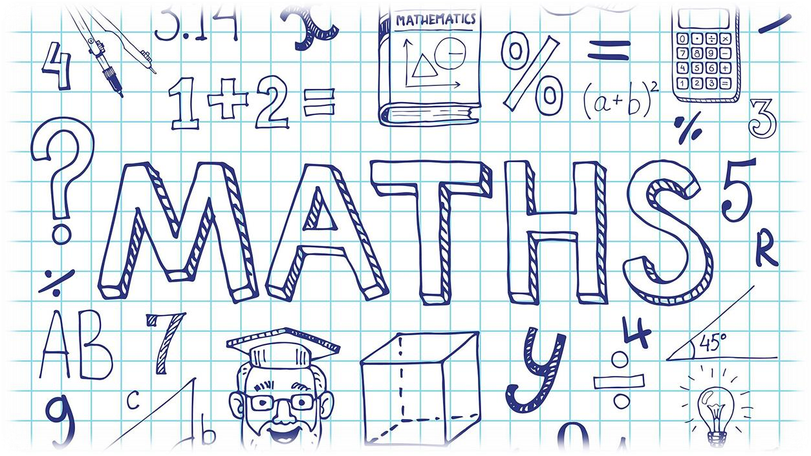
Year 6 to 7 Maths Transition Pack
Message from the Head of Department

We are all looking forward to meeting you in September but until then we have put together some Maths activities to continue to develop your maths skills.

You will come across the activities during your time at Ruskin Community High School which will help with your numeracy and problem-solving skills.

At Ruskin we want you to enjoy your time in maths so that you can make the best possible progress you are capable of to help you succeed later in life. No matter the path you take in life; maths will play a vital part so let’s work together to make sure you leave school fully equipped with the mathematical skills you need to have the best options available to you.

Good luck and the Maths Team and I look forward to meeting you in September

Mrs J Bell

Tick or Trash

At Ruskin we like to use something called “Tick or Trash”

These are worksheets that require you to decide who has the correct answer based on your mathematical understanding and skills developed in primary and in maths class at Ruskin.

Sometimes one has got the right answer but every now and then both could be correct or both wrong. These are designed to get you thinking about the questions and to help you understand that some questions have multiple answers (e.g. powers, units).

Task: Round each question to the given number of places. Find who has the correct answer (neither could have it or both could be right) and shade that box in. The one with the most correct answers at the end is the winner.

Have a go at the following activities on some important maths topics from both primary and secondary school. Working out is encouraged as in maths it’s not just about getting the right answer, it’s about your methods and effort.

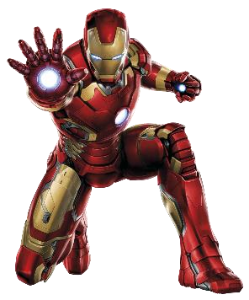
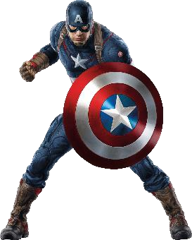
(A) ROUNDING
1 | 200 | 248 to the nearest hundred. | 300
2 | 600 | 576 to the nearest 10. | 580
3 | 7 | 6501 to the nearest thousand. | 6000
4 | 10000 | 9951 to the nearest hundred. | 9900
5 | 4000 | 5320 to the nearest thousand. | 5000
6 | 8 | 8.43 to the nearest whole number. | 8.00
7 | 9 | 9.72 to the nearest whole number. | 10
8 | 1.2 | 1.2354 to 1 decimal place. | 1.1
9 | 6 | 1.583 to 2 decimal places. | 1.6
Maths Genius Question!
A number is rounded to the nearest whole number. The answer is 24. Give 3 possible numbers that have been rounded.
Maths Legend Question!
Use rounding to estimate: 17 x 2.5

4 | P a g e

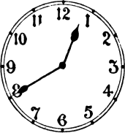
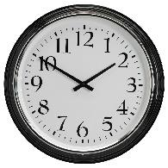
(B) TIME
1 | 12:40 |  | 01:40
2 | 1:50am |  | 13:50
3 | 16:20 | 20 past 4 (Afternoon) | 4:20 pm
4 | 11:20 | 11:20pm | 23:20
5 | 3:07pm | 15:07 | 3:07am
6 | 9:00am | Bedtime | 9:00pm
7 | 07:00 | Breakfast | 7:00pm
8 | 12:10 | 10 past midnight | 00:10
9 | 12:10 | 10 past midday | 00:10
Maths Genius Question!
Give a time (12 hours and 24 hour) where the following is likely to happen:
a) Do Homework b) Eat Lunch c) Wake up

5 | P a g e

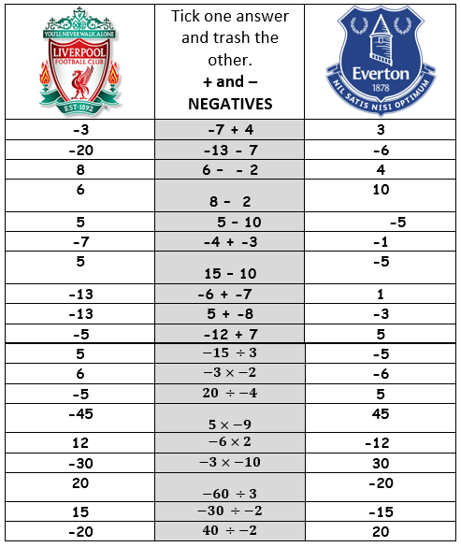
(C) NEGATIVES

6 | P a g
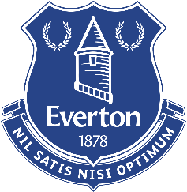
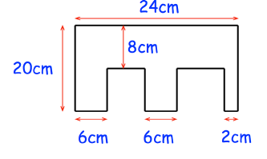
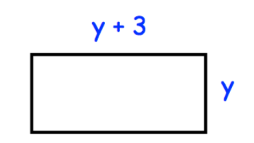
(D) AREA
1 | 20cm | Find the area of a rectangle with sides of length 4cm and 5cm. | 20cm2
2 | 24cm | Find the perimeter of a square with side length of 6cm. | 36cm2
3 | 1.2m2 | Find the area of a rectangle with side lengths 60cm and 2m. | 1200cm2
4 | 84cm2 | Find the area of a trapezium with parallel lines of length 5cm and 9cm with a height of 6cm | 42cm2
5 | 35cm2 | Find the area of a triangle with a base of 5cm and a height of 7cm. | 17.5cm
6 | 4πcm2 | Find the area of a circle with radius 2cm. (HINT: Use Area=πr2 | 12.566……cm2
Maths Genius Question!
Find the area and perimeter of the shape below.
Maths Legend Question!
1. Give an expression for the area and perimeter of the shape:

2. The area of a shape is 32cm2 – In your books draw two possible shapes that have this area.

9 | P a g e

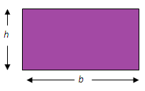
(E) ALGEBRA – Simple equations
7
5
 |  | Question
1 | x = 6 | 2x = 8 | x = 4
2 | x = 5 | x + 7 = 12 | x = 17
3 | x = 19 | 3x = 21 | x = 7
4 | x = 17 | x – 9 = 8 | x = 1
5 | y = 10 | 𝑦 = 3 | y = 21
6 | t = 9 | 𝑡 = 45 | t = 225
7 | x = 13 | 2x + 7 = 19 | x = 6
8 | x = 8 | 5x + 8 = -32 | x = -8
9 | x = 1.5 | 2y + 10 = 13 | no answer
Mathematical Understanding
10 | A=1, B=2, C=3…..Z=26 because that’s its position in the alphabet | Letters in maths. What do they actually mean? | Letters represent unknown numbers of any type. These can be decimals or integers
EXTENSION - USING AND APPLYING
Write an expression for the perimeter of this rectangle

10 | P a g e

(F) FRACTIONS OF AN AMOUNT
3
5
7
6
3
3
3
9
8
5
7 5
 |  | Question
1 | 5 | 𝐹𝑖𝑛𝑑 2 𝑜𝑓 15 | 10
2 | 24 | 𝐹𝑖𝑛𝑑 4 𝑜𝑓 30 | 25
3 | 6 | 𝐹𝑖𝑛𝑑 2 𝑜𝑓 21 | 14
4 | 8 | 𝐹𝑖𝑛𝑑 5 𝑜𝑓 48 | 40
5 | 15 | 𝐹𝑖𝑛𝑑 2 𝑜𝑓 21 | 14
6 | 9 | 𝐹𝑖𝑛𝑑 1 𝑜𝑓 27 | 3
7 | 14 | 𝐹𝑖𝑛𝑑 10 𝑜𝑓 70 | 21
8 | 8 | 𝐹𝑖𝑛𝑑 1 𝑜𝑓 72 | 9
9 | 21 | 𝐹𝑖𝑛𝑑 3 𝑜𝑓 64 | 24
MATHS GENIUS QUESTION
Alex says that 2 of 60 is 12
Is he right?
MATHS LEGEND QUESTION
𝑊ℎ𝑖𝑐ℎ 𝑖𝑠 𝑏𝑖𝑔𝑔𝑒𝑟 3 𝑜𝑓 28 𝑜𝑟 4 𝑜𝑓 20

11 | P a g e

